4/1/2026
Bug Slayers
Michael Fuentes, Christopher Ledford, Emirhan Tektas
EzPlay SYSTEM
REQUIREMENTS DOCUMENT
DRAFT

Table of Contents
Introduction 1
Description Model 1
Class Diagram 1
Use Case Diagram 1
Use Case Scenarios 1
System Sequence Charts 1

Introduction (ET)
This document details the system requirements for the EzPlay system and outlines the technical framework for all our features. The Description Model describes in detail the outputs, inputs, processes, performance, and security of each feature. The Class Diagram outlines the entities, methods, and relationships in the EzPlay system. The Use Case Diagram and Descriptions visualizes the use cases for EzPlay and then discusses the step-by-step process of each use case. The final System Sequence Diagram ties everything into a visual representation of the actors in each use case and the interactions they would have with the EzPlay system. These visual and descriptive models offer a deeper look into the system's architecture and the specific interactions between users and the EzPlay environment.

Description Model (CL)
*account creation requirements for example, that type of technical stuff for each feature, performance stuff & response time

*using AWS for all as a database

General Functions
- Input
  - Mouse and keyboard input is read by EzPlay.
  - The user can send friend requests, which travel through EzPlay’s servers.
- Output
  - Once the user logs in, the account logged into is sent to the user.
  - The system will receive a user-sent friend request and send it to the proper account.
- Processes
  - Friends can be added by searching for their username. This friends list is held and used for functions within features.
  - Each core feature, PlayRoom, DealPlay, and CloudGaming, can all be deleted or installed individually.
- Performance
  - Every account will have a linked username, email and password. While the email and passwords can both be changed, one email can only be linked to one account, the system will not permit two or more accounts to share the same email. The same goes for an account’s username, there will not be any username repeats allowed. The user can also change their username similarly to their email and password, however it can only be changed once every 24 hours.
  - Friend lists will not have a max friend count.
- Security
  - EzPlay information will be held in a database with AWS, protected through Amazon’s security.
  - Accounts will be protected with a simple login system, using an account’s email address and password to login. If a password is forgotten a request to change the password is sent to the email linked to the account.
  - There will be basic bot protection on the login screen through a CAPTCHA.

PlayRoom
- Input
  - Keyboard input is necessary to send messages.
  - Mouse left clicking is read when selecting a game.
  - Microphone input will be read when in a call.
- Output
  - Microphone input from others is sent to the user’s headphones as output.
  - Messages sent by other users will be displayed in a feed.
  - When a game is selected, EzPlay sends the game to the user.
- Processes
  - A group can be created where users can send messages, call, or play small games. Group invites can be sent through a username search or your friend list.
  - Messages can be sent and deleted.
  - Clipping can be done with a keyboard press
    - Clips will record the past 30 seconds prior to the clip keybind being pressed. The video file is then sent to a file within EzPlay’s download directory. In the PlayRoom, clips saved to this file can be modified to shorten clip length and then exported as a new video file.
- Performance
  - Games will be designed to hold 2-8 people.
  - A group in PlayRoom can hold a max of 35 people with a 500MB file size limit.
  - The resolution of a clip can be modified in PlayRoom settings.
  - Games can be disabled in the PlayRoom settings. This makes it so the user will not see notices of a game being started and prevents game information from being held in the user’s system, slightly helping performance.
  - The message feed in general and the call feature can each be individually disabled. This does not disable these features globally in a group, but rather similarly to the game disabling it is just done individually on the user’s end. This can be done to optimize performance from the user’s system if one or the other is not needed for whatever reason.
- Security
  - EzPlay will request mic permissions from the user when a call is joined

DealPlay
- Input
  - Keyboard input is read when utilizing the search bar function.
  - When filtering results, mouse left click input is read as toggles are switched.
- Output
  - Following a search, a list of games is then displayed to the user with the results displaying titles close in name to what the user searched.
  - When a starred game goes on sale, EzPlay displays an alert to the user in the starred games area.
- Processes
  - The user will have the option to search for a game from a search bar.
  - The user will have the option to filter search results.
  - The user will be able to star games, to quickly find out when and if they are on sale.
  - Games searched for frequently will automatically be displayed in a “Hot Deals” section when they are discounted by 35% or more.
- Performance
  - DealPlay will refresh once every 30 minutes to update deals.
- Security
  - Store sites linked to DealPlay are manually picked, in order to prevent it from being filled with fake game listings from unofficial store sites.
  - If connection to a store site is temporarily down, DealPlay will continue to display the previously received deals, but with a warning message telling the user that the deal may be outdated.

CloudGaming
- Input
  - In addition to keyboard and mouse, basic controllers will be supported and read as input.
  - When hosting a cloud gaming session, the host’s system effectively is reading the host’s own input as well as the input of the friend joining the session, both directly to the host’s system.
  - The user’s payment information must send a form of payment through credit/debit card or paypal.
- Output
  - A flag on the user’s account is flipped in order to indicate that their subscription service is now active once payment has been received and processed.
  - The streamed cloud game’s display from the EzPlay gaming servers is sent live to the users.
  - Users joining a gaming session send their input over to the host’s system.
  - Users utilizing EzPlay’s CloudGaming gaming servers send their own input over to the connected gaming servers, where it is then read locally.
- Processes
  - The user can use EzPlay’s CloudGaming service to run games through EzPlay’s gaming servers, which are then streamed to the user allowing them to play games which their own system is not strong enough to run.
  - The owner of an EzPlay CloudGaming subscription service can host a gaming session, allowing friends who are not subscribed to also connect to EzPlay’s gaming servers and play with the host. This feature only works on games with multiplayer.
  - If the user is not subscribed to the subscription service, or the user wishes to host a game not hosted on EzPlay’s gaming servers, the user to select a game of their choice to host for a multiplayer cloud gaming gaming service. What this means is that the user will run the game locally from their system, while a friend connects to their system, treating the host’s system similarly to how they would have connected to EzPlay’s gaming servers.
- Performance
  - It is recommended to have a 10 Mbps (megabytes per second) download and upload speed to run our cloud gaming service, whether it is playing singleplayer or joining another’s session hosted on our cloud gaming service.
  - When personally hosting a game session, it is also recommended to have at least 10 Mbps download and upload speed. Unlike when using our cloud gaming service, as a host your computer must also be strong enough to run whatever game you are hosting at a consistent rate.
  - When joining a game session, the same 10Mbps download/upload speed is recommended.
  - EzPlay gaming servers will have high enough specs to safely target 60fps at 4k in every game in our catalog.
  - Just like other Cloud Gaming services, EzPlay’s CloudGaming will have a slight input lag, higher than it would normally be if games were run natively from the user’s system. The input lag will be roughly 75 milliseconds, which may trend slightly upwards or downwards depending on the user’s connection strength to EzPlay’s gaming servers.
  - Self-hosting a gaming session is a process that is done through EzPlay linking an account to the host, but it does not use EzPlay’s gaming servers, instead it uses the host’s system as the base server. This means that the host will need a very strong system to support their own running of the game in addition to the other joining their game.
- Security
  - Using EzPlay’s cloud gaming service operates with a client-server relationship, with EzPlay’s security defending personal information such as your IP address. When joining another’s gaming session, Peer-to-peer is used instead, making your IP address vulnerable. As such, it should only be used with those you trust, such as close friends. When hosting a session, the one who joins is also able to send input directly to your system from their own output. While they can only send input in the hosted game, it may be something to be wary of.
  - The user’s payment information is stored within EzPlay following the purchase of the subscription service, however the user has the option to remove their payment information following purchase of the service. This would cancel the service upon renewal date but it is also an option to ensure auto-renewal does not occur if the user is concerned about that.

Class Diagram (ET)
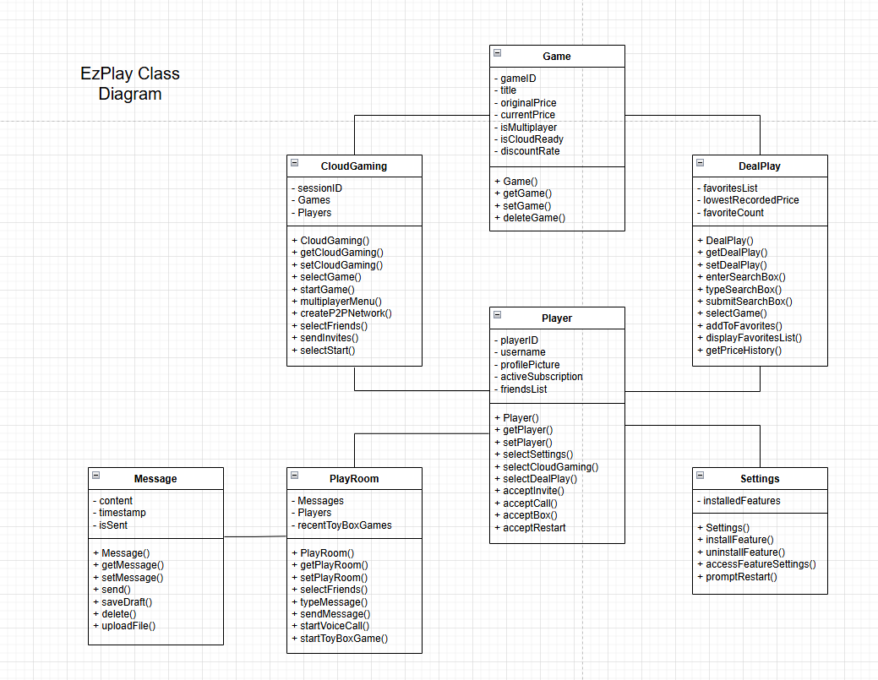
If Not Showing, See Additional Files

Use Case Diagram (MF)
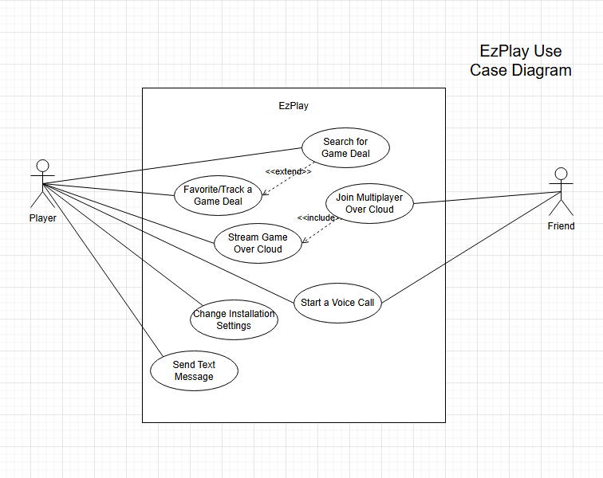
If Not Showing, See Additional Files

Use Case Scenarios (MF)
See Additional Files

System Sequence Charts (MF)
See Additional Files

